**AI in Finance: Understanding key drivers of AI-assisted decision-making in Rules-Based Investment**

*Jérôme Pacher*

*Fabian Gubler*

The AI Economy: Business Strategies and Policy Issues

Summer School 2022, University of Basel

# Introduction

Financial institutions around the globe are increasingly incorporating technological advances into their business operations. The entrepreneurial startup community plays a key role in this transformation through the development of new Financial Tech (FinTech) applications, which “dramatically change the way financial services and products are delivered” (Hill, 2018). The biggest challenge for these institutions is breaking free from existing patterns and comfort levels of the past (Marous, 2015). Similarly, Matteo Rizzi (2015) argues that the duty of the financial sector shouldn’t be to fight the disruption, but to embrace it.

Artificial intelligence in FinTech is playing an important role in the disruption of financial services by replacing both simple and complex human activities (Abdul, 2019). Investment Banking increasingly incorporates the growing discipline of Data Science and its subset Artificial Intelligence into their decision-making processes.

In the following, the paper will provide insight into key drivers of AI within the financial industry. The first chapter gives an overview of Rules-Based Investment and investigates its opportunities. Following, the second chapter will examine Natural Language Processing to expand Rules-Based learning on the basis gathering novel financial information. At last, the paper closes with a conclusion, which summarizes the main findings and discusses their relevance.

# Rules-Based Investing

When investors invest money, they usually try to predict developments on the financial markets. These forecasts often turn out to be wrong in retrospect. Many predictions overestimate the strength and duration of price rises and fail to recognise a price slump in time. Investors therefore make excessive losses in falling markets.

Simple Rules can be derived from past price developments, which investors can apply without forecasts and which protect them from making irrational decisions. The Rules can be implemented quickly in crisis situations, for example; they are clear and transparent in their effect. The Rules are based on empirical values and thus differ fundamentally from mathematical models that seek to predict future developments. The investor defines the Rules before the initial investment, tests them against historical data and checks their behaviour in different market cycles. As soon as the set of Rules is in place, human influence is Rulesd out. The Rules make all investment decisions in a disciplined and uncompromising manner and prevent emotional wrong decisions. In the following sections, some common Rules are discussed.

*Rebalancing*

One of the predefined Rules in Rules-Based Investing is the underlying asset allocation strategy, i.e. the division of the portfolio into different asset classes and their percentage share. During a market cycle, the relative shares of the asset classes change constantly, caused by the varying performance of the asset classes. As a result, the asset allocation also changes and deviates from the defined strategic allocation. Therefore, the allocation should be periodically adjusted back to the target strategy.

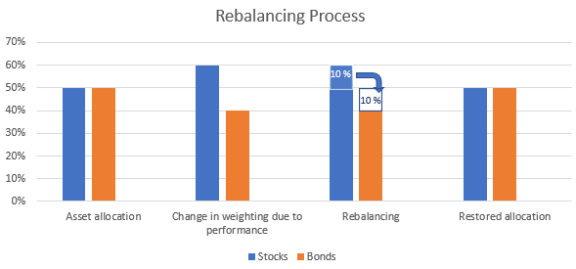

Figure 1: Rebalancing illustration

*Relative Strength*

Comparing trend strengths of different asset classes can define another underlying Rules. This involves investing in those asset classes that generated the strongest performance or the highest trading volume in a given market cycle. In a boom phase, for example, investments could be made increasingly in shares of the technology sector, which historically performed best in this market phase. In a recession, on the other hand, an overweight in bonds and shares of defensive sectors can lead to a better performance. The relative strength is therefore a key figure for measuring the momentum of an asset class or sector and comparing it with a predefined benchmark universe, e.g. a cross sector benchmark index.

*Dynamic Stop-Loss-Orders*

In the financial markets, especially in recessionary phases, major market distortions can occur from time to time. Within a few days or even hours, enormous amounts of market capitalisation can be wiped out, driven by panic, herd mentality and risk aversion.

In order to protect yourself from such market turbulences, you can set sell orders that are executed when a certain price is reached. Such stop-loss orders are already widespread and are used depending on the investor's risk capacity. A possible further development would be the dynamic structure of such stop-loss orders, i.e. the periodic adjustment of the stop-loss orders. In this case, the sell orders are periodically recalculated and set on a certain deadline. If there is a market correction of e.g. >10% per day from the opening price, the position of the security is automatically sold. With this tool, you can protect yourself from large market corrections and avoid larger losses. Using machine learning, an algorithm could even adjust the margin depending on the market phase, P/E ratio or momentum of the security.

# Natural Language Processing

Information is at the heart of Rules-Based Investment as it is essential in powering these decisions. To achieve real-time applications, these systems traditionally rely on the inflow of structured and quantitative data. This approach neglects the huge set of relevant textual data that can be found in articles, press release statements and posts on social networks. In order to expand the dataset and utilize these untapped forms of data Natural Language Processing (NLP) shows many opportunities to extract textual information in a short period of time.

Hirschberg and Manning (2015) define NLP as the employment of “computational techniques for the purpose of learning, understanding, and producing human language content”. Early NLP approaches focused on the analysis of language structure and developed basic machine translation technologies. Today’s real-world NLP applications are able to mine social media for information and are subsequently able to identify sentiment and emotion. To achieve such complex tasks, the processing of natural language is deeply tied to various areas of Artificial Intelligence. Multiple areas are needed to be able to reason about textual information in order to understand intentions and social conventions (Eisenstein, 2019).

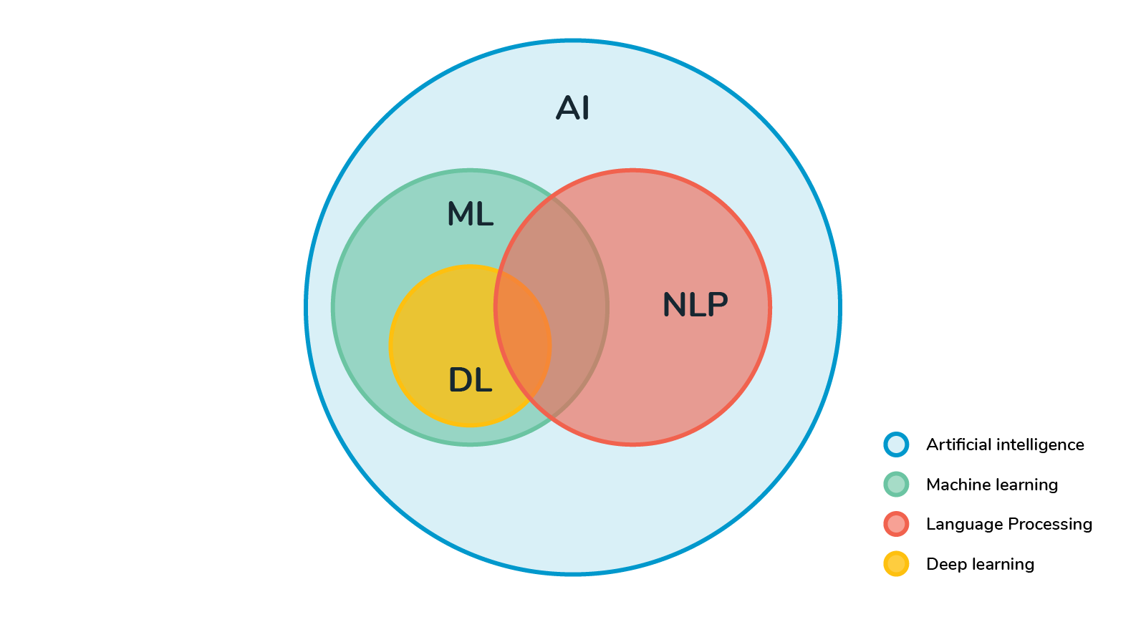

Figure 2: NLP in the context of Artificial Intelligence (Sathiyakugan, 2018)

In the context of a Rules-Based Investment approach, incorporating machine learning and text analytics provides NLP the potential of classifying and discovering patterns from electronic financial documents to inform decisions. In this context, NLP enables the transformation of unstructured data into a structured form that is suitable for analysis and the application of machine learning algorithms. (Raghupathi et al., 2020)

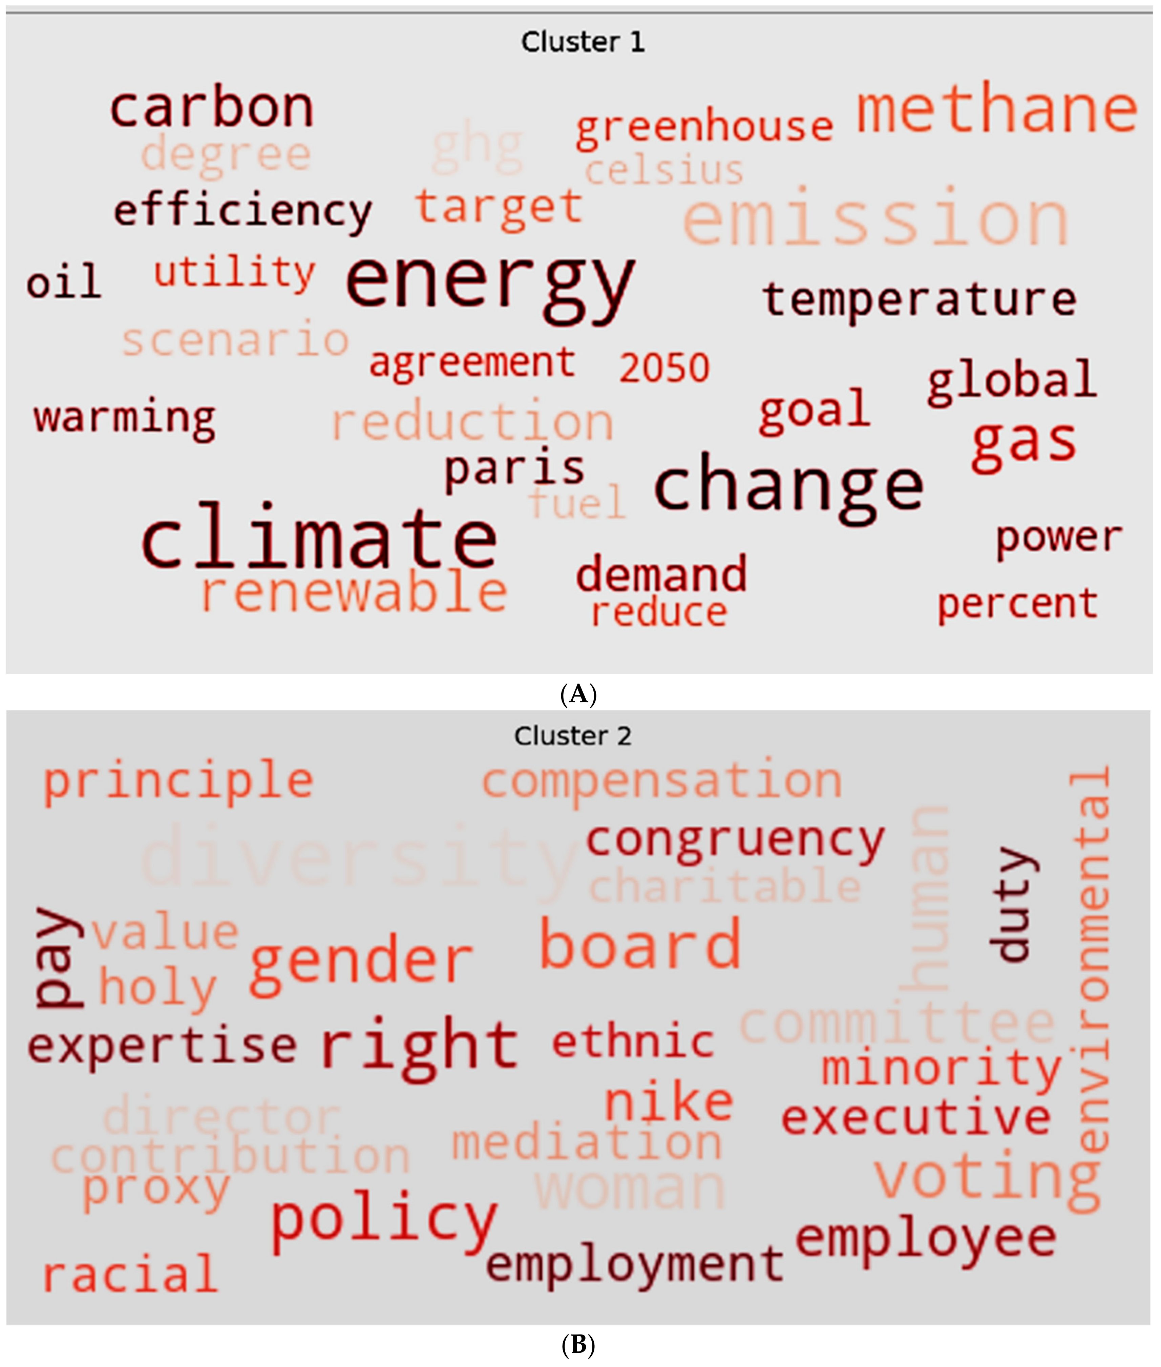

Figure 3: Prevalence of Words associated with energy emission (Raghupathi et. Al, 2020)

For instance, Figure 2 provides a concrete example of using NLP to aid in investing decisions regarding environmental, social and governance (ESG) data. Based on 449 sustainability resolutions Raghupathi et al. (2020) identified internal sustainability efforts regarding energy emissions using machine-learning text analytics. By making use of Big Data in combination with NLP models, investment decisions can be improved in order to allocate capital towards companies that “manage themselves in a socially responsible way” (Antoncic, 2020). By uncovering hidden signals in unstructured text, NLP provides mechanism to combat self-reported bias and greenwashing carried out by companies.

# Conclusion

Therefore, implementing NLP into existing investment decisions allows to increase the dataset of relevant financial information powering Rules-Based Investment. In addition, by using unstructured textual data systems can alleviate biases created by benchmarks and ratings. Furthermore, taking unstructured data into consideration Rules-Based Investment has the potential to increase returns and reduce risks associated with a mere quantitative data analysis approach.

Rebalancing, Relative Strength and the Dynamic Stop-Loss-Orders are just three of the many possible rules that can be applied to Rules-Based Investing. The possibilities are almost unlimited, but depend heavily on regulatory conditions, the risk capacity of investors and performance ambitions. Furthermore, a broad usage of Rules-Based Investing can actually amplify the severity of market disruptions, stop-loss orders can escalate into a real downward spiral and should therefore be used consciously.

# 

# References

[Abdul, R. (2019). *FinTech as a Disruptive Technology for Financial Institutions*. IGI Global.](https://www.zotero.org/google-docs/?ztps1D)

[Antoncic, M. (2020). Uncovering hidden signals for sustainable investing using Big Data: Artificial intelligence, machine learning and natural language processing. *Journal of Risk Management in Financial Institutions*, *13*(2), 106–113.](https://www.zotero.org/google-docs/?ztps1D)

Burton G. Malkiel; “A random walk down wallstreet” (2019) – pp. 99-100

Daniel Seiler; “Artificial Intelligence in investing” (2018) by Vesocre, Bank Vontobel

[Eisenstein, J. (2019). *Introduction to Natural Language Processing*. MIT Press.](https://www.zotero.org/google-docs/?ztps1D)

[Hill, J. (2018). *Fintech and the Remaking of Financial Institutions*. Academic Press.](https://www.zotero.org/google-docs/?ztps1D)

[Hirschberg, J., & Manning, C. D. (2015). Advances in natural language processing. *Science*. https://doi.org/10.1126/science.aaa8685](https://www.zotero.org/google-docs/?ztps1D)

[Marous, J. (2015, April 27). The Most Influential Voices In Banking. *FinServ 25*. https://www.linkedin.com/pulse/finserv-25-most-influential-voices-banking-jim-marous/](https://www.zotero.org/google-docs/?ztps1D)

[Raghupathi, V., Ren, J., & Raghupathi, W. (2020). Identifying Corporate Sustainability Issues by Analyzing Shareholder Resolutions: A Machine-Learning Text Analytics Approach. *Sustainability*, *12*(11), 4753. https://doi.org/10.3390/su12114753](https://www.zotero.org/google-docs/?ztps1D)

[Rizzi, M. (2015, April 27). *28 of The Most Influential Voices In Banking*. The Financial Brand. https://thefinancialbrand.com/news/banking-trends-strategies/top-25-influencers-leaders-finserv-banking-51541/](https://www.zotero.org/google-docs/?ztps1D)

[Sathiyakugan, B. (2018, July 26). *Learn Natural Language Processing from scratch*.](https://www.zotero.org/google-docs/?ztps1D)

Medium. https://blog.goodaudience.com/learn-natural-language-processing-from-

scratch-7893314725ff